Rotary type electrical tape label packaging machine ZRB-1625X
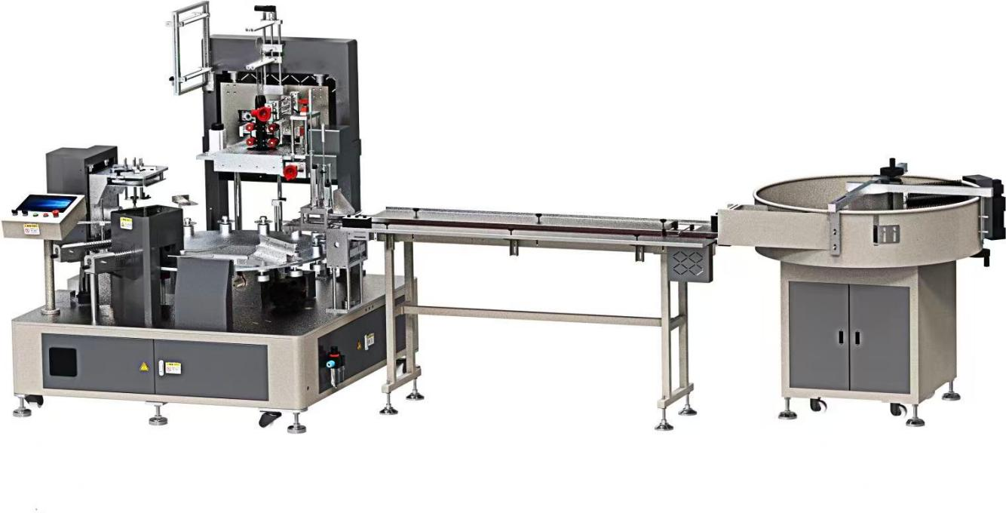
Equipment layout diagram：

Basic Use：
The direct in electrical tape labeling and packaging machine is used for automatic material handling and loading of single roll electrical tape, as well as shrink film and paper card packaging.
Equipment Advantages:
- High speed and stability, packaging 50 pcs/min.
- Man-machine interface, microcomputer programmable control.
- 5 servo control, servo motor control chain plate positioning, high-precision transmission; Servo positioning film feeding (adjustable length) film pulling; Servo control suction mark; Servo control marking, stable performance; Servo controlled blade for precise film cutting.
- 2-station rotary vacuum suction and label placement, with the label plate sensing in place, no label replacement, and continuous operation without stopping the machine.
- Automatic material management, automatic feeding, automatic contraction, to achieve unmanned production.
- Automatic material management, automatic feeding, automatic contraction, to achieve unmanned production.
- Replacement specifications without tool disassembly, fast and convenient, easy to adjust.
- Integrated vacuum generator is used to realize the integrated design, automatic control and regulation, and improve the stability.
- The feeding shaft adopts cantilever manual rising shaft, which is simple and stable.
- Simple operation, automatic fault alarm, one-key intelligent operation.
Main Technical Parameters：
Model | ZRB-1625X
Packing width | 15-25mm
Packing diameter | 50-130mm（Non-standard Customized）
Packing speed | 50pcs/Min
Power | AC380V-4P 8.5KW
Power of brushless welding gun | 1.5KW/2PCS
Air supply pressure | 0.5mpa
Packaging film thickness | 0.035-0.04mm（Shrinkage  50%）
Machine size | 2150mm*1955mm*2052mm  2065mm*578mm*1025mm  1335mm*1350mm*1342mm
Net Weight | 2100KG
Configuration Parameters:
Model number | Rotary type electrical tape label packaging machine ZRB-1625X
Touchscreen | Display control
Turntable servo | Hokawa
Turntable drive | Hokawa
Film delivery servo | Hokawa
Film delivery drive | Hokawa
Film cutting servo system | Hokawa
Film cutting drive | Hokawa
Suction target servo | Hokawa
Vacuum marker driver | Hokawa
Reducer | Smart
Separator | Extremely long
PLC controller | Hokawa
Air switch | Zhengtai
Contactor | Schneider
Switching power supply | Mingwei
Speed control motor | Mili
Photoelectric switch | Yangming
Solid-state relay | Yangming
Relay | Koizumi
Thermostat | Tatsuzumi
Frequency converter | Kosovo
Push button switch | Schneider
Cylinder | Stars
Filter | Artistry of Nature
Solenoid valve | Artistry of Nature
Integrated vacuum generator | Aiko
Magnetic switch | Yadeke
Vacuum generator | Painbo
Bearing | NSK
Frame | Imported powder coating spraying
Fiber amplifier | Bo Yi
Motion controller | Hokawa
Photoelectric sensor | Bo Yi
Reducer | Mili
Hot air gun | Qinqi
Guide rail | Shangyin
Vacuum cylinder | Dingcheng

